LAPORAN PRAKTIKUM
Pertemuan : 4
MK: Metode Statistika II
Materi: Membuat Chart (Bar Chart, BoxPlot Chart, Scatterplot )

- BAR CHART
Sintaks R:

#Pertemuan 4, dan 5
#Membuat Grafik (Creating bar charts of group means)

#Membuat Diagram Batang
#Load Data
?InsectSprays
spray <- InsectSprays #Load data with shorter name

#To plot means, first get the means for the groups
means <- aggregate(spray$count ~ spray$spray, FUN = mean)
means
plot(means) #Gets lines for means

#To get a barplot, need to extract means and reorganize
mean.data <- t(means[-1]) #removes first columns, transposes second
colnames(mean.data) <- means[, 1]

#Basic barplot for means
barplot(mean.data)

#Modified barplot
barplot(mean.data,
col = "lightblue",
main = "Effectiveness of Insect Sprays",
xlab = "Spray Used",
ylab = "Insect Count")

Output:
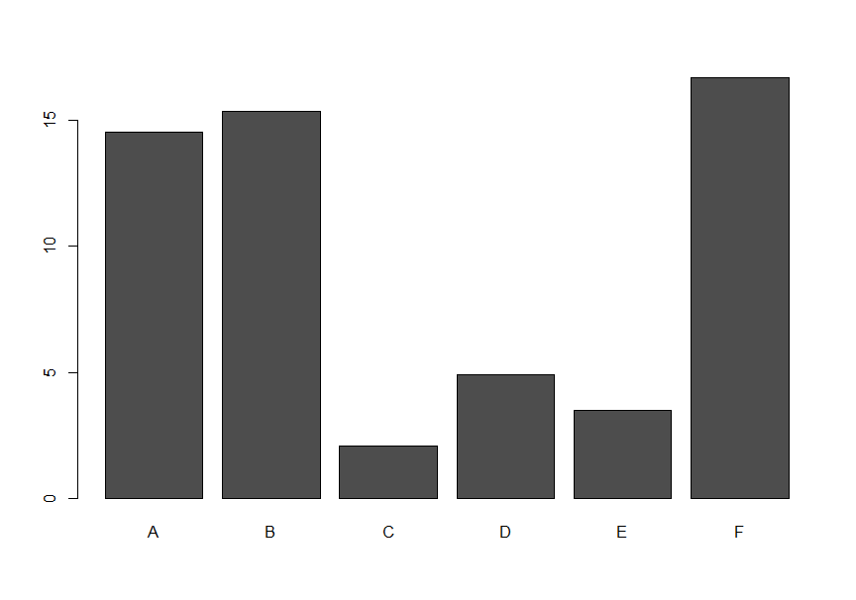
#Grafik Mentah

#Grafik Olahan

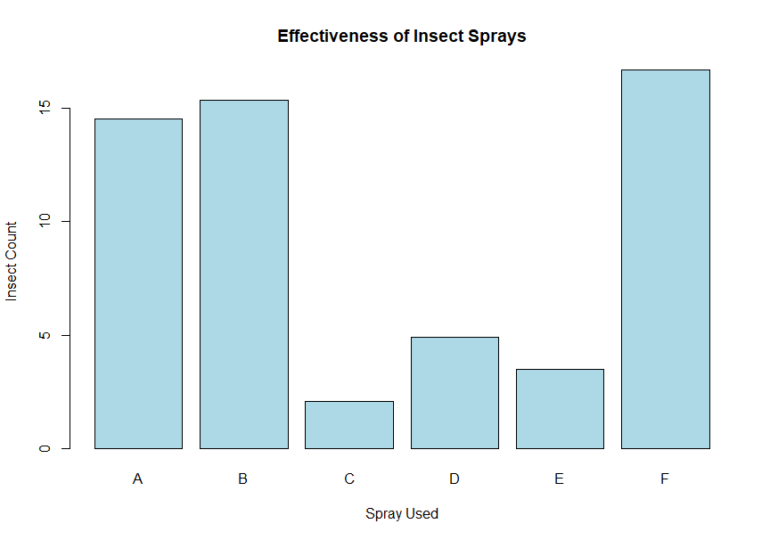

- BOXPLOT CHART
Sintaks :

#Pertemuan 4, dan 5
#Membuat Grafik (Creating bar charts of group means)

#Membuat Diagram Batang
#Load Data
?InsectSprays
spray <- InsectSprays #Load data with shorter name

#To plot means, first get the means for the groups
means <- aggregate(spray$count ~ spray$spray, FUN = mean)
means
plot(means) #Gets lines for means

#To get a barplot, need to extract means and reorganize
mean.data <- t(means[-1]) #removes first columns, transposes second
colnames(mean.data) <- means[, 1]

#Basic barplot for means
barplot(mean.data)

#Modified barplot
barplot(mean.data,
col = "lightblue",
main = "Effectiveness of Insect Sprays",
xlab = "Spray Used",
ylab = "Insect Count")

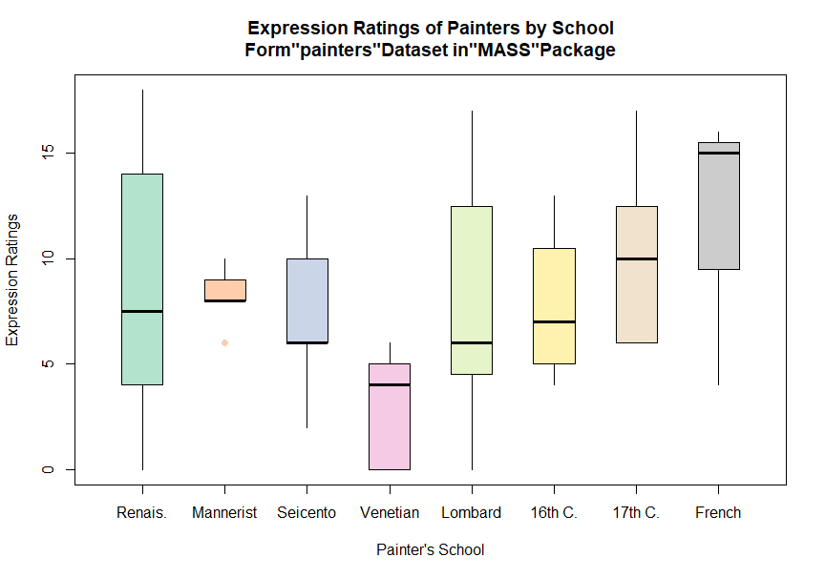
Output Grafik:

Interpretasi :
Di Tengah setiap boxplot terdapat garis tebal itu merupakan garis rata-rata data keseluruhan. Misalnya pada bar (data) pertama, bermakna kebanyakan data menyebar di atas nilai rata-rata keseluruhan data. Terdapat titik berwarna nila pada bar kedua yang bermakna outlier data. Dst.

- SCATTERPLOT CHART (KASUS REGRESI LINEAR)
Sintaks:

#Pertemuan 4, dan 5
#Membuat Grafik (Creating bar charts of group means)

#Membuat Diagram Scatterplot

#Load Data
?cars
data(cars)
cars

#Basic scatterplot
plot(cars)

#Modified scatterplot
plot(cars,
pch= 16,
col = "gray",
main="Speed vs. Stopping for Cars in 1920s\nForm\"cars\"Dataset",
xlab= "Speed (MPH)",
ylab=" Stopping Distance (feet)")
#Linear Regression Line
abline(lm(cars$dist ~ cars$speed),
col="darkred",
lwd=2)

#"Locally weighted scatterplot smoothing"
lines(lowess (cars$speed, cars$dist),
col="blue",
lwd=2)

#"cars" packages ("Companion to Applied Regession")
#has many variations on scatterplots
install.packages("car")
help(package="car")
require(car)

#scatterplot has marginal boxplots, smoothers, dan quantile regression intervals
scatterplot(cars$dist~cars$speed,
pch = 16,
col = "darkblue",
main="Speed vs. Stopping for Cars in 1920s\nForm\"cars\"Dataset",
xlab= "Speed (MPH)",
ylab="Stopping Distance (feet)")

#clean up

detach("package: car", unload=TRUE)
rm(list=ls())

Output Grafik Scatterplot :

#Grafik Mentah
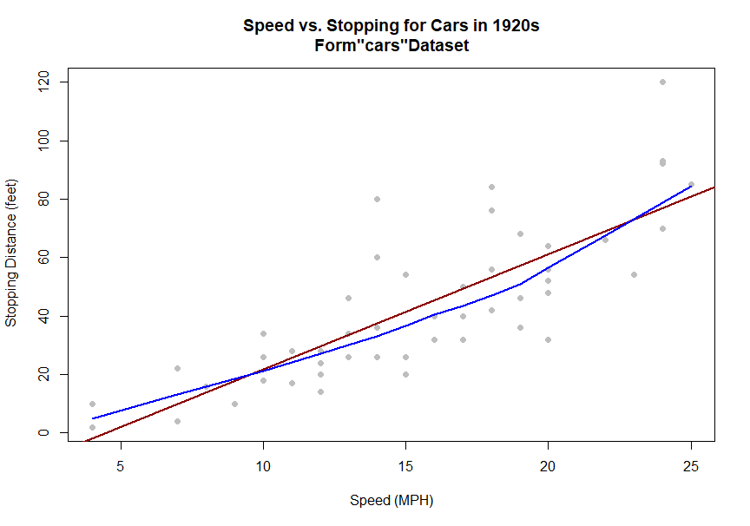

Interpretasi :
Garis biru bermakna bahwa setelah data diberikan bobot (diberikan proporsi), saat datanya banyak dia cenderung ke bawah. Sedangkan garis merah adalah garis linear regresi yang menunjukkan apakah ada pengaruh antarvariabelnya atau tidak.

#Grafik Olahan
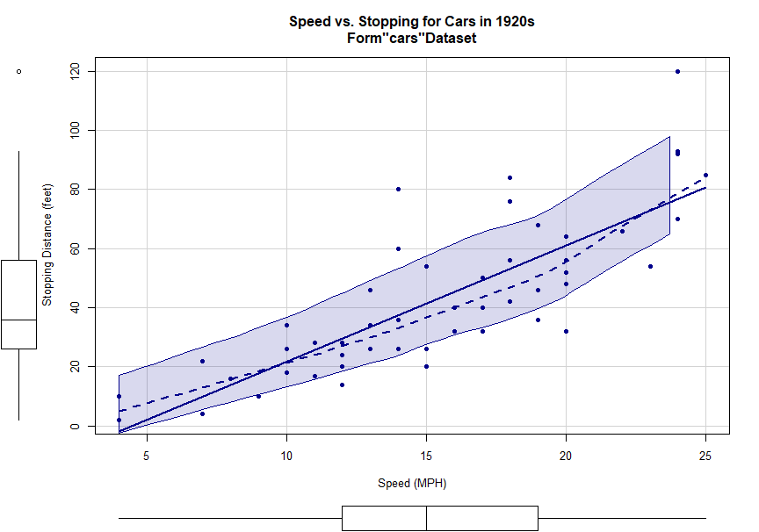

Interpretasi :
Data banyak tersebar pada rentang daerah bayang biru.

